**JAVA JSP**

**What Is a JSP Page?**

A **JSP page** is a text document that contains two types of text: static data, which can be expressed in any text-based format (such as [HTML](http://www.w3.org/MarkUp/), [SVG](http://www.w3.org/TR/SVG), [WML](http://xml.coverpages.org/wap-wml.html), and [XML](http://www.w3.org/TR/REC-xml/)), and JSP elements, which construct dynamic content.

The recommended file extension for the source file of a JSP page is .jsp. The page can be composed of a top file that includes other files that contain either a complete JSP page or a fragment of a JSP page. The recommended extension for the source file of a fragment of a JSP page is .jspf. The JSP elements in a JSP page can be expressed in two syntaxes, standard and XML, though any given file can use only one syntax. A JSP page in XML syntax is an XML document and can be manipulated by tools and APIs for XML documents.

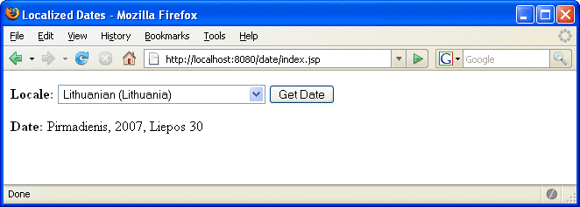

The lines in bold in the example code contain the following types of JSP constructs:

* A page directive (**<%@page ... %>**) sets the content type returned by the page.
* Tag library directives (**<%@taglib ... %>**) import custom tag libraries.
* **jsp:useBean** is a standard element that creates an object containing a collection of locales and initializes an identifier that points to that object.
* JSP expression language expressions (**${ }**) retrieve the value of object properties. The values are used to set custom tag attribute values and create dynamic content.
* Custom tags (see [Chapter 8, Custom Tags in JSP Pages](http://docs.oracle.com/javaee/5/tutorial/doc/bnalj.html)) set a variable (**c:set**), iterate over a collection of locale names (**c:forEach**), and conditionally insert HTML text into the response (**c:if**, **c:choose**, **c:when**, **c:otherwise**).
* **jsp:setProperty** is another standard element that sets the value of an object property.
* A function (**f:equals**) tests the equality of an attribute and the current item of a collection. (A built-in == operator is usually used to test equality.)

**Here is the JSP page:**

<%@ **page contentType**="text/html; charset=UTF-8" %>

<%@ **taglib** uri="http://java.sun.com/jsp/jstl/core

"

prefix="c" %>

<%@ **taglib** uri="/functions" prefix="f" %>

<html>

<head><title>Localized Dates</title></head>

<body bgcolor="white">

<**jsp:useBean** id="locales" scope="application"

class="mypkg.MyLocales"/>

<form name="localeForm" action="index.jsp" method="post">

<**c:set** var="selectedLocaleString" value="**${param.locale}**" />

<**c:set** var="selectedFlag"

value="**${!empty selectedLocaleString}**" />

<b>Locale:</b>

<select name=locale>

<**c:forEach** var="localeString" items="**${locales.localeNames}**" >

<**c:choose**>

<**c:when** test="**${selectedFlag}**">

<**c:choose**>

<**c:when**

test="**${f:equals(selectedLocaleString, localeString)}**" >

<option selected>**${localeString}**</option>

</c:when>

<c:otherwise>

<option>**${localeString}**</option>

</c:otherwise>

</c:choose>

</c:when>

<**c:otherwise**>

<option>**${localeString}**</option>

</c:otherwise>

</c:choose>

</c:forEach>

</select>

<input type="submit" name="Submit" value="Get Date">

</form>

<**c:if** test="${selectedFlag}" >

<**jsp:setProperty** name="locales"

property="selectedLocaleString"

value="**${selectedLocaleString}**" />

<**jsp:useBean** id="date" class="mypkg.MyDate"/>

<**jsp:setProperty** name="date" property="locale"

value="**${locales.selectedLocale}**"/>

<b>Date: </b>**${date.date}**</c:if>

</body>

</html>